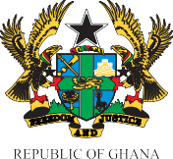

A REPORT ON GARID SENSITIZATION AT MATAHEKO ON FLOOD
DATE: 15TH MAY, 2024
OBJECTIVE
The GARID project seeks to improve flood risk and solid waste management in the Odaw River Basin of the Greater Accra Region, improve access to basic infrastructure and services in targeted communities within the Odaw River Basin.
INTRODUCTION
As part of the ways in reducing flood in Greater Accra region the Ablekuma Central Municipal Assembly engages mataheko community on the causes of floods, its effects and preventive measures. They were also made aware of their duties and responsibility as citizens. They were also caution against burning of refuse as it depletes the ozone layer and also pollutes the environments coupled with it dire health consequences.
The meeting started at 11:00am with a prayer by one of the participants.
DISSCUSSION
The resource persons educated the community on the need to keep their refuse properly and to avoid dumping of refuse into drains anytime the clouds gather. They were also caution against burning of refuse as it affects health negatively, deplete the ozone layer and pollutes the environment. They were made to understand that sanitation is a shared responsibility, they are to help the environmental health officers so that they will intern help them solve their sanitation issues/concerns. They were also caution against discharging of their toilet contents into drains at night and during heavy down pour.

They were made to understand that they are the eyes of the Assembly during odd hours.
Some Concerns raised by the community members are:
- They want to see the environmental health officers more often
- The big drain at Dan Lartey stretch need to be de-silted
- Drains within the community is too narrow hence needs expansion
- They want more of these kind of engagements.
CONCLUSIONS
The meeting ended at 1:25 with questions from operators which will be attended to in due time. A closing prayer was said.
Picture gallery;
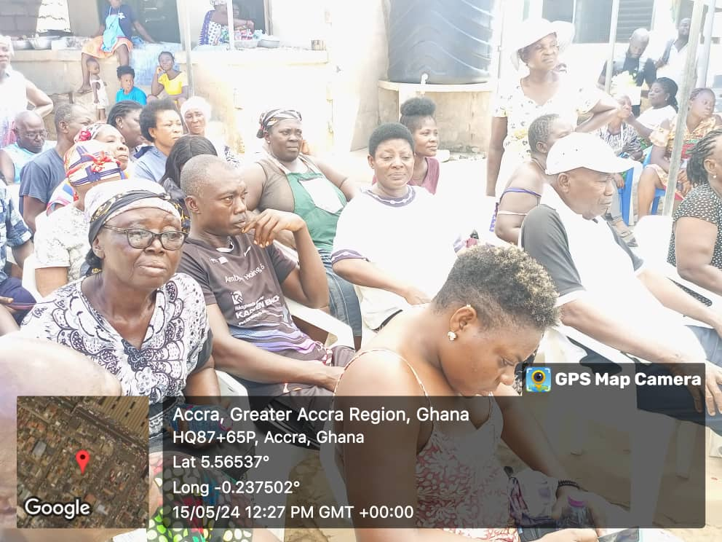Community members gathered for the engagement
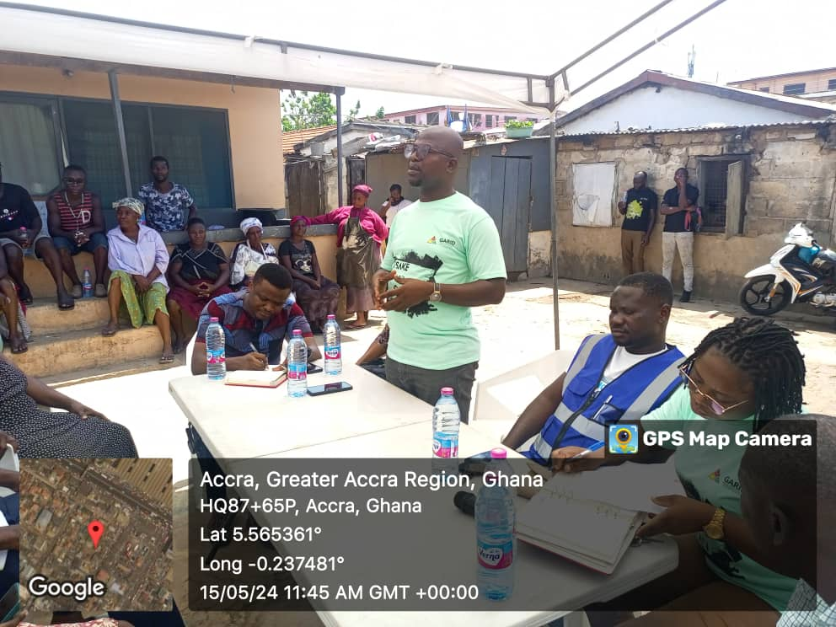Engagement on-going by the Assembly
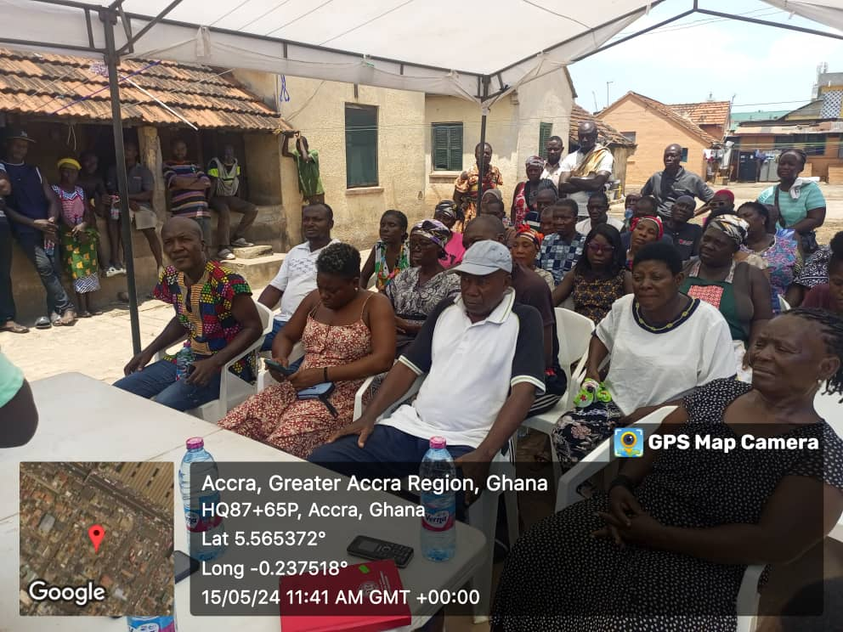
Community members listening to the interactions
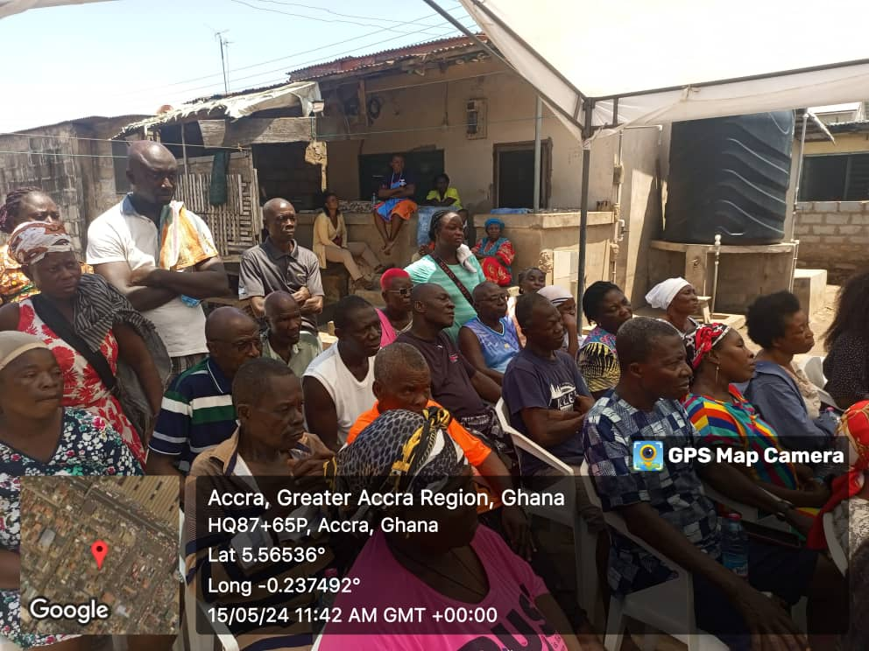Section of members gathered doing the listening
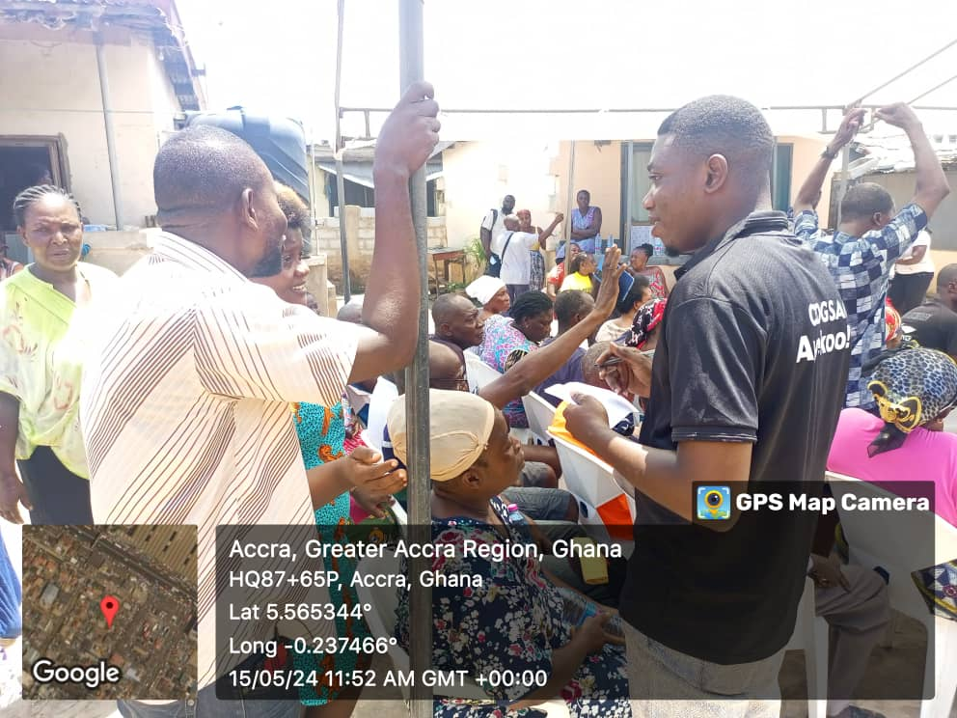E.H.O taking attendance of participants
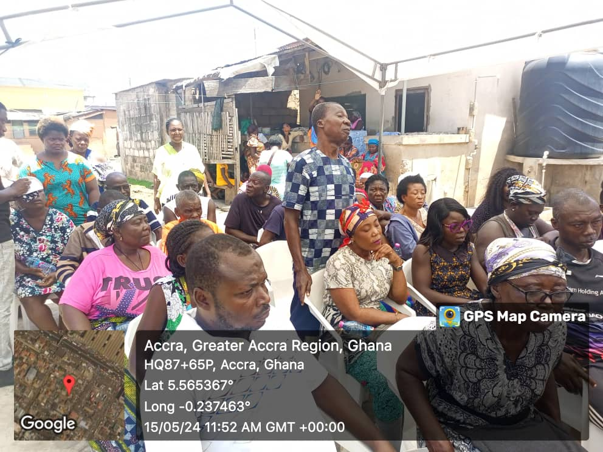Members asking questions and bringing their views
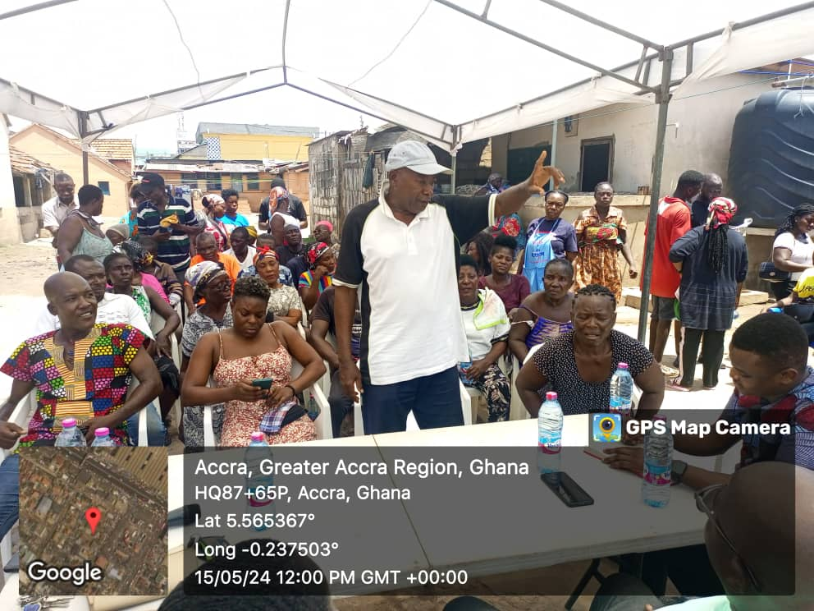Members asking questions and bringing their views
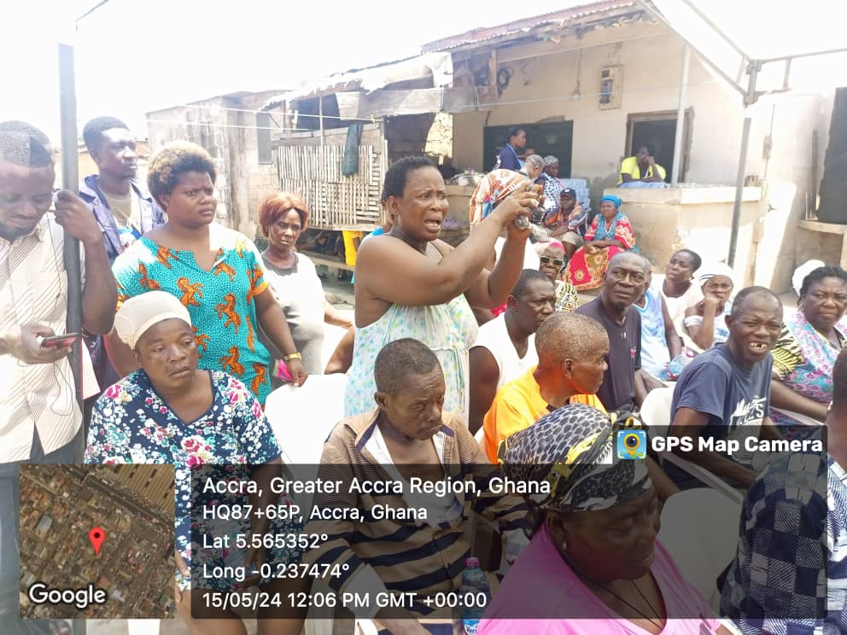 Members asking questions and bringing their views
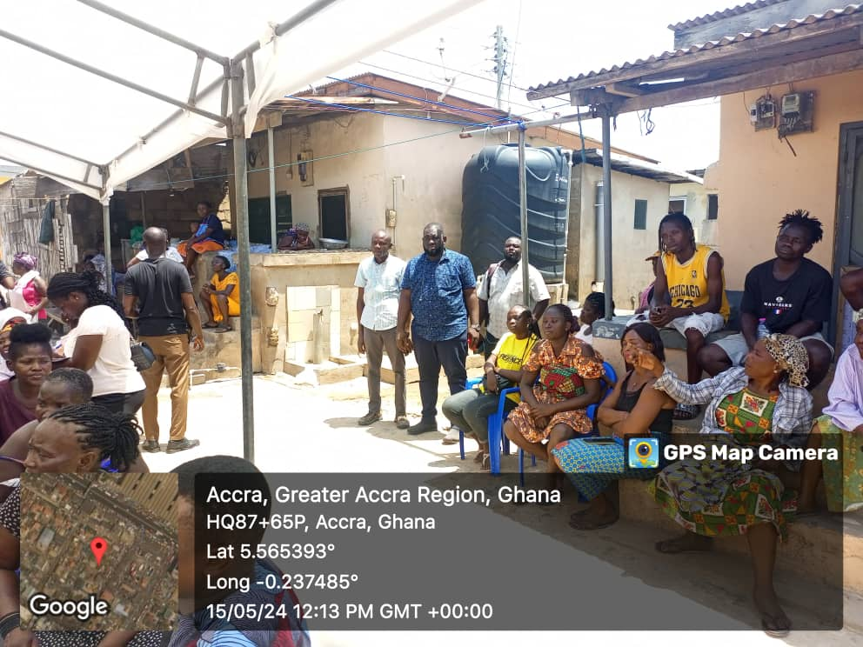Over flow section of members
Thank You.

BRIDGET SEYRAM DIAPIM
(MUNICIPAL ENVIRONMENTAL HEALTH OFFICER)

